Innovation Showcase: February 2023, Volume 18, Number 2

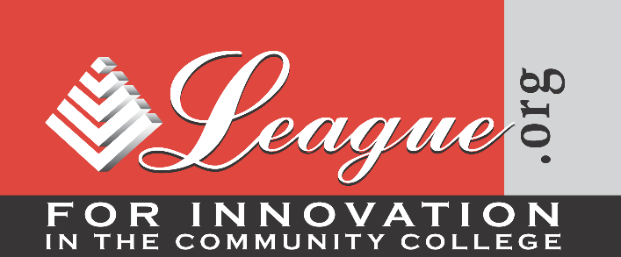

Will This Continuing Dilemma Ever Be Solved?

By Terry O'Banion

In January of this year, Inside Higher Ed (IHE) reported on a meeting between tech executives and presidents of small private colleges in the article, “Preaching to, and Challenging, the Liberal Arts Choir” (Lederman, 2023). The meeting took place in San Francisco in a special session at the annual meeting of the Council of Independent Colleges. IHE (Lederman, 2023) reported that, “In a conversation with presidents of small private colleges, tech company executives praise graduates’ leadership and critical thinking ability but say they need to develop skills for a first job, too” (subheadline).

This is a never-ending conversation that has been going on perhaps since Neanderthals occupied caves in the Dordogne region of France (O’Banion & Miles, 2022) and continues today as one of the most intensive and unresolved issues in American higher education. The tech company executives echoed the perspectives of many leaders from the workforce education side of the issue (Lederman, 2023):

- “If we’re hiring based on skills, that’s going to open up much more opportunity for a more equitable and diverse workplace. That doesn’t mean that there’s less value to a degree, but there are more avenues to those who earn those skills in other ways” (para. 5).
- “Colleges should think in terms of ‘both/and’—delivering a four-year degree grounded in the liberal arts that remains the best preparation for a lifetime career but also building into their curricula more practical digital and other skills that can help graduates compete for a first job” (para. 6).
- “Your institutions can help that student develop, discover, find their purpose and passion, while they’re picking up all kinds of skills along the way” (para. 7).

The key message of the article was clearly stated: “Much work remains to be done to infuse more practical experience and skill development into the general education and liberal arts curriculum” (para. 20). Easier said than done.

There is some hope for movement on this issue. The tech representative from Futuro Health indicated that the company has developed its curriculum to prepare people to work in health care information technology by taking a set of courses designed to develop six core interpersonal skills, including empathy and compassion in healthcare, cultural competence, effective communication, emotional intelligence, teamwork and collaboration, and ethnics and integrity, before they take any technical courses. These are the soft skills increasingly championed by business and corporations as necessary for the nation’s workers.

In an article published by IHE in August 2020, the author argued for a both/and curriculum that would help students make a good living and live a good life. In 2016, the League for Innovation in the Community College published the same author’s monograph, Bread and Roses: Helping Students Make a Good Living and Live a Good Life, which was designed to create a framework for an integrated curriculum while helping to resolve the historical divide between liberal education and workforce education. The author recommended a new term for the integrated curriculum: an “Essential Education” for all students that would bridge the divide. It would be what some advocates have identified as a liberal career education or a practical liberal education.

The monograph includes a brief history of workforce education and of general education—the version of liberal education most prevalent in community colleges—and recommends seven different approaches faculty can use to create a revised curriculum that reflects the both/and framework. Faculty are the primary target of the document since they are the ones responsible for curricular reform, and there’s the rub. Former president, Woodrow Wilson, said, “It is easier to change the location of a cemetery, than to change the school curriculum.”

So, will this continuing dilemma ever be resolved? Even with support from business and industry for an integrated curriculum and proposed solutions by education leaders, the future is not bright for resolution. A few community colleges are addressing the issue, but if there is to be major reform, more leadership is required from community college presidents and academic administrators who will need to work with faculty to create an Essential Education for all students. Without action from college leaders and faculty, this continuing dilemma will never be resolved, and community college students, in particular, will continue to suffer the consequences.

References

Lederman, D. (2023, January 10). Preaching to, and challenging, the liberal arts choir. Inside Higher Ed. https://www.insidehighered.com/news/2023/01/10/role-liberal-arts-era-skills-based-hiring

O’Banion, T. (2016). Bread and roses: Helping students make a good living and live a good life. League for Innovation in the Community College.

O’Banion, T. U. (2020, August 27). An Essential Education for All Students. Inside Higher Ed. https://www.insidehighered.com/views/2020/08/27/major-curricular-reform-community-colleges-requires-new-paradigm-opinion

O’Banion, T., & Miles, C. L. (2022, September). An innovation that could transform the community college world. Learning Abstracts, 25(9). League for Innovation in the Community College.

Terry O’Banion is Senior Professor of Practice, Kansas State University, and President Emeritus, League for Innovation in the Community College.

Opinions expressed in Innovation Showcase are those of the author(s) and do not necessarily reflect those of the League for Innovation in the Community College.

